Automatic Control of Aircraft, AE40019
Instructor: Shikha Hota
Project: Simulation of the paper, “Analysis and Design of Launch Vehicle Flight Control Systems, by Bong Wie and Wei Du, Iowa State University, Ames, IA 50011-2271 and Mark Whorton, NASA Marshall Space Flight Center, Huntsville, AL 35812”

Name: Dheeraj
Roll No: 22AE30009

Introduction
The paper chosen describes the fundamental principle of launch vehicle flight control analysis and design. In particular, designing the control system for pitch angle control with particular focus on the classical concept of “drift-minimum” and “load minimum” control principles.

Theory
Considering a simplified linear dynamical model of a launch vehicle. As illustrated in figure below, as follows:
$$\ddot{θ}=M_{α}α+M_{δ}δ$$
$$\ddot{Z}= -\frac{F}{m}θ-\frac{N_{α}}{m}α+\frac{T}{m}δ$$
$$α= θ+\frac{\dot{Z}}{V}+α_{w}$$
$$F=T_{0}+T-D$$
Where, $θ$ is the pitch attitude, $α$ the angle of attack, $Z$ the inertial Z-axis drift position of the center-of-mass, $\dot{Z}$ the inertial drift velocity, $m$ the vehicle mass, $T_{0}$ the un-gimbled sustainer thrust, $T$ the gimbaled thrust, $N = N_{α}α$ the aerodynamic normal (lift) force acting on the center-of-pressure, $D$ the aerodynamic axial (drag) force, $F$ the total x-axis force, $δ$ the gimbal deflection angle, $V$ the vehicle velocity, $α_{w} =\frac{V_{w}}{V}$ the wind-induced angle of attack, $V_{w}$ the wind disturbance velocity, and
$$M_{α}=\frac{N_{α}}{I_{y}}x_{cp}$$
$$M_{δ}=\frac{T}{I_{y}}x_{cg}$$
$$N_{α}=\frac{1}{2}ρV^{2}SC_{N_{α}}$$
Where $I_{y}$ is the pitch moment of inertia. For an effective thrust vector control of a launch vehicle, we need
$$M_{δ}δ_{max}>M_{α}α_{max}$$
Where $δ_{max}$ is the gimbal angle constraint and $α_{max}$ is the maximum wind induced angle of attack.

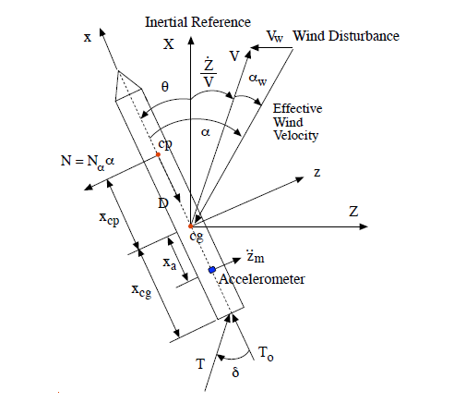
Figure 1 Simplified pitch-axis model of the launch vehicle

For a 3rd order dynamical model of the form,
$$\frac{d}{dt}\left[\begin{matrix}θ \\ \dot{θ} \\ α\end{matrix}\right]=\left[\begin{matrix}0 & 1 & 0 \\ 0 & 0 & M_{α} \\ -F/mV & 1 & -N_{α}/mV\end{matrix}\right]\left[\begin{matrix}θ \\ \dot{θ} \\ α\end{matrix}\right]+\left[\begin{matrix}0 \\ M_{δ} \\ T/mV\end{matrix}\right]δ+\left[\begin{matrix}0 \\ 0 \\ \dot{α_{w}}\end{matrix}\right]$$
The control variable be
$$δ= -K_{1}θ-K_{2}\dot{θ}-K_{3}α$$

Now if we find the close loop transfer function from the disturbance $α_{w}\left(s\right)$ to the drift velocity $\dot{Z}\left(s\right)$, angle of attack $α(s)$ and gimbal angle $δ\left(s\right)$ as
$$\frac{\dot{Z}\left(s\right)}{α_{w}\left(s\right)V}=-\frac{A_{2}s^{2}+A_{1}s+A_{0}}{s^{3}+B_{2}s^{2}+B_{1}s+B_{0}}$$
$$\frac{α\left(s\right)}{α_{w}\left(s\right)}=\frac{s\left(s^{2}+M_{δ}K_{2}s+M_{δ}K_{1}\right)}{s^{3}+B_{2}s^{2}B_{1}s+B_{0}}$$
$$\frac{δ\left(s\right)}{α_{w}\left(s\right)}=\frac{s\left({K_{3}s}^{2}+M_{α}K_{2}s+M_{α}K_{1}\right)}{s^{3}+B_{2}s^{2}B_{1}s+B_{0}}$$

where
$B_{2}=M_{δ}K_{2}+\frac{T}{mV}\left(K_{3}+\frac{N_{α}}{T}\right)$
$B_{1}=M_{δ}\left(K_{1}+K_{3}\right)-M_{α}+\frac{K_{2}T}{mV}\left(M_{α}+\frac{M_{δ}N_{α}}{T}\right)$
$B_{0}=\frac{TK_{1}}{mV}\left(M_{α}+\frac{M_{δ}N_{α}}{T}\right)-\frac{F}{mV}\left(M_{δ}K_{3}-M_{α}\right)$
$A_{2}=\frac{T}{mV}\left(K_{3}+\frac{N_{α}}{T}\right)$
$A_{1}=\frac{K_{2}T}{mV}\left(M_{α}+\frac{M_{δ}N_{α}}{T}\right)$
$A_{0}=B_{0}$

Now finding the steady state value of the drift velocity, when the wind disturbance is a constant step function $α_{w}\left(s\right)=1/s$
$$\frac{{\dot{Z}}_{ss}}{V}=\lim_{s→0}{s×\frac{1}{s}×}-\frac{A_{2}s^{2}+A_{1}s+A_{0}}{s^{3}+B_{2}s^{2}+B_{1}s+B_{0}}=-\frac{A_{0}}{B_{0}}=-1$$
$$⟹ {\dot{Z}}_{ss}=-V$$
Since, we can notice that the steady state drift velocity does not depend on the gains set by us, that means we can not control the steady state drift velocity, but if we make $B_{0}=0$, steady state value become,
$$\frac{{\dot{Z}}_{ss}}{V}=-\frac{A_{1}}{B_{1}}=-\frac{1}{1+C}$$
Where
$C=\frac{mV\left[M_{δ}\left(K_{1}+K_{3}\right)-M_{α}\right]}{M_{α}K_{2}T+M_{δ}N_{α}/T}$

Now for, stable closed loop system, the thrusters must have the necessary control to negate the moments generated by the aerodynamic forces, this implies, $M_{δ}\left(K_{1}+K_{3}\right)-M_{α}>0$, we have $C>1$, implies $\left|{\dot{Z}}_{ss}\right|<V$, since the steady state values of $δ=α=0$, then the maximum lateral velocity can be the wind disturbance, $V_{w}$, hence $\left|{\dot{Z}}_{ss}\right|<V_{w}$.
Hence, the condition, $B_{0}=0$ is the Drift minimum condition, can be rewritten as,
$$\frac{M_{δ}K_{3}-M_{α}}{M_{δ}K_{1}}=\frac{N_{α}}{F}\left(1+\frac{x_{cp}}{x_{cg}}\right)$$
Now for load minimum case, since we know that total moment acting on the launch vehicle is the sum of the effects due to angle of attack, $α$ and gimbal angle $δ$. Hence upon minimizing the steady state values of $α$ and $δ$ will give the load minimum condition.
Since, steady state values,
$$α_{ss}=M_{δ}K_{1} and δ_{ss}=M_{α}K_{1}$$
From the above expressions if we see that, upon putting $K_{1}=0$ will give the minimum steady state angle of attack and steady state gimbal angle. This is the condition for Load minimum control of the launch vehicle.

Analysis and Design
For the vehicle considered in the paper, with specifications,
$Iy = 2.43E6 slug-ft^{2},$ $m = 5830 slug,$ $T = 341, 000 lb$,
$F = 375, 000 lb,$ $xcp = 38 ft,$ $xcg = 32.3 ft$, $V = 1320\frac{ft}{sec},$
$V_{w} = 132\frac{ft}{sec},$ $α_{w}= 5.73 deg$, $Nα = 240, 000\frac{lb}{rad},$ $Mα = 3.75 s^{-2}, M_{δ} = 4.54 s^{-2}$
And gimbal actuator has 2nd order dynamics,
$$δ\left(s\right)=\frac{ω_{n}^{2}}{s^{2}+2ζω_{n}s+ω_{n}^{2}}δ_{c}(s)$$
This implies that after setting the gains using the pole placement method the control input goes from the actuator dynamics and serves to the actual system.

The plant
$$\dot{X}=AX+Bδ$$
$$Y=CX$$
For observing all the states, $C=eye(3)$
$$X=\left[\begin{matrix}θ \\ \dot{θ} \\ α\end{matrix}\right], A=\left[\begin{matrix}0 & 1 & 0 \\ 0 & 0 & M_{α} \\ -F/mV & 1 & -N_{α}/mV\end{matrix}\right], B=\left[\begin{matrix}0 \\ M_{δ} \\ T/mV\end{matrix}\right]$$
Since gimble actuator has 2nd order response, then gimble system,
$$\dot{\overline{X}}=\overline{A}X+\overline{B}δ_{c}$$
Since, $δ_{c}=-KX$, then,
$$\dot{\overline{X}}=\overline{A}\overline{X}-\overline{B}KX$$
And,
$$δ=\overline{C}\overline{X}$$
Where,
$$\overline{X}=\left[\begin{matrix}δ \\ \dot{δ}\end{matrix}\right], \overline{A}=\left[\begin{matrix}0 & 1 \\ -2500 & -100\end{matrix}\right], \overline{B}=\left[\begin{matrix}0 \\ 2500\end{matrix}\right], \overline{C}=\left[\begin{matrix}1 & 0\end{matrix}\right]$$
Putting the value of δ in plant equation, the overall equation become,
$$\dot{X}=AX+B\overline{C}\overline{X}$$
$$\dot{\overline{X}}=\overline{A}\overline{X}-\overline{B}KX$$
$$Y=CX$$
Since we also want to get the values of drift and drift velocity,
Adrift = [0 0 0 0 0 0 1;-(F/m) 0 -(N_alpha/m) (T/m) 0 0 0];

now combining these into one system equation,
$$\dot{\tilde{X}}=\tilde{A}\tilde{X}$$
$$\tilde{Y}=\tilde{C}\tilde{X}$$
Where,
$$\tilde{X}=\left[\begin{aligned}\begin{matrix}θ \\ \dot{θ} \\ α\end{matrix} \\ δ \\ \dot{δ} \\ Z \\ \dot{Z}\end{aligned}\right]$$
$\tilde{A}$ = [A, B*Ctilda, zeros([3,2]);-Btilda*K, Atilda, zeros([2,2]);Adrift];

Results
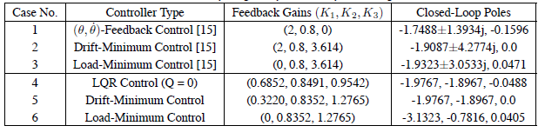
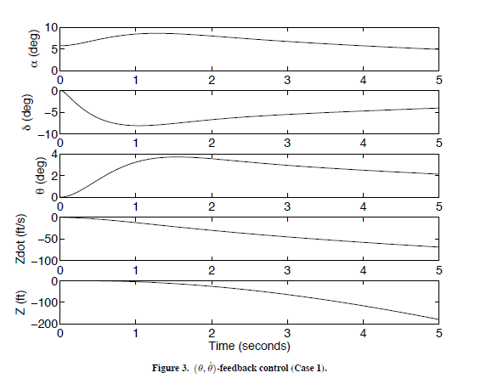

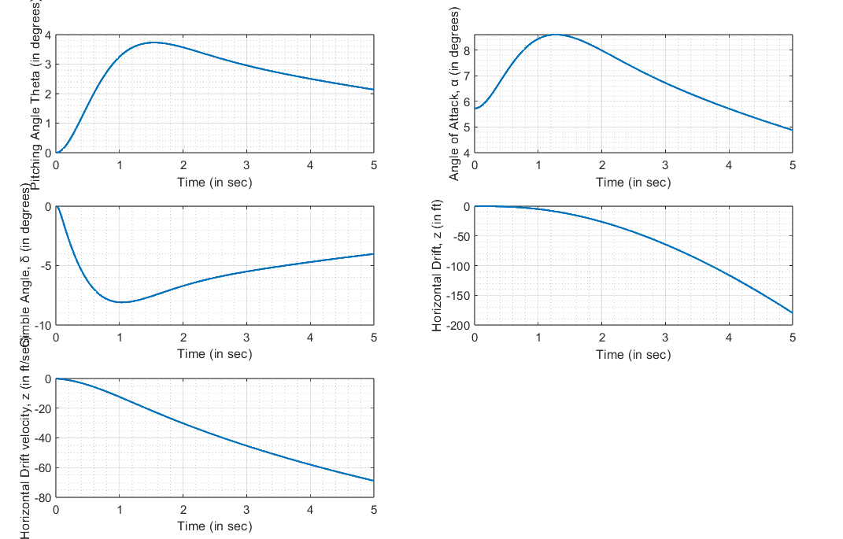
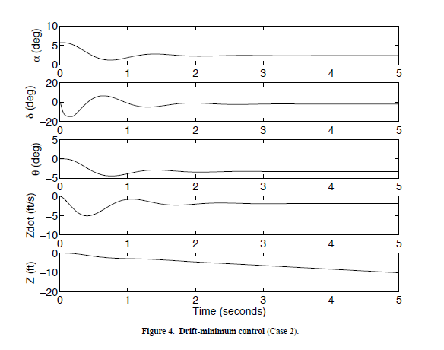
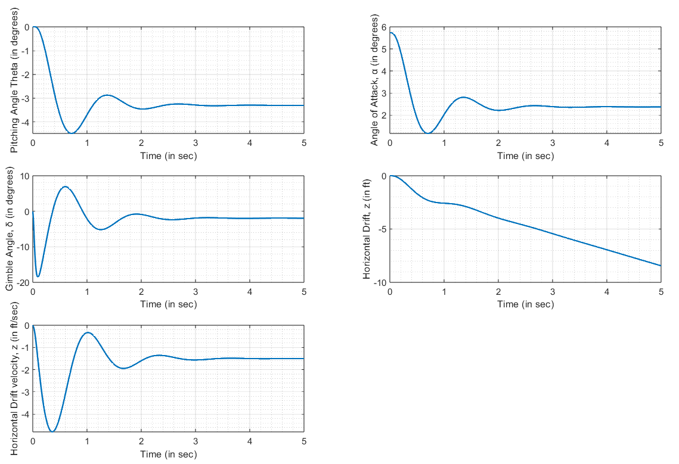

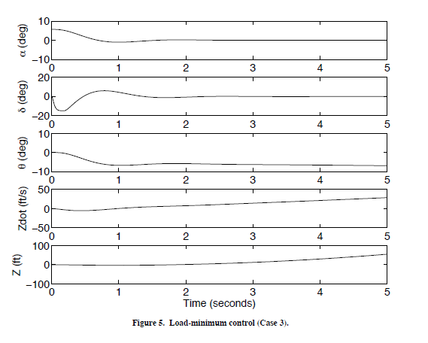
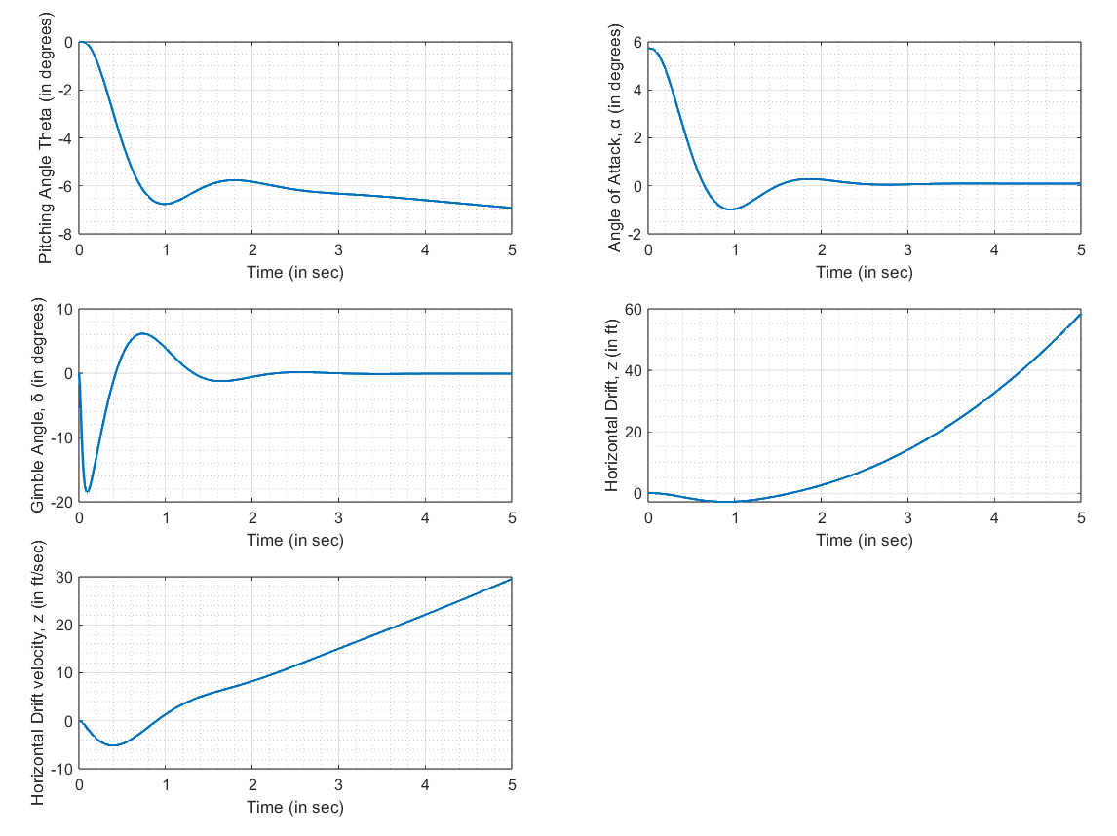
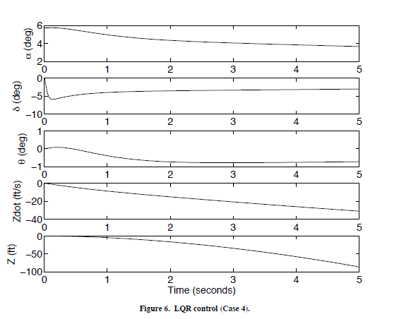
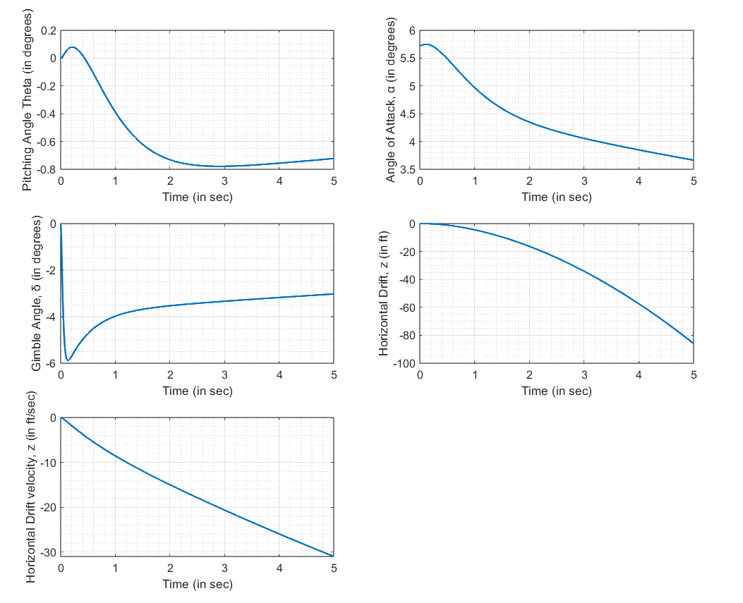

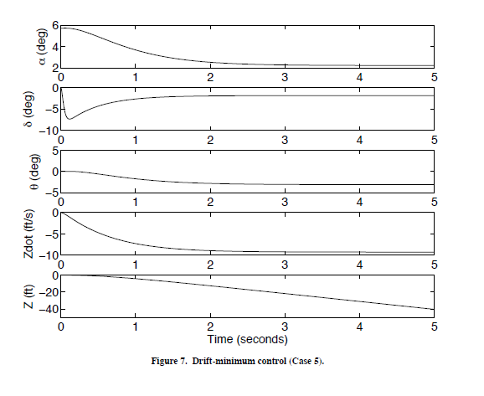
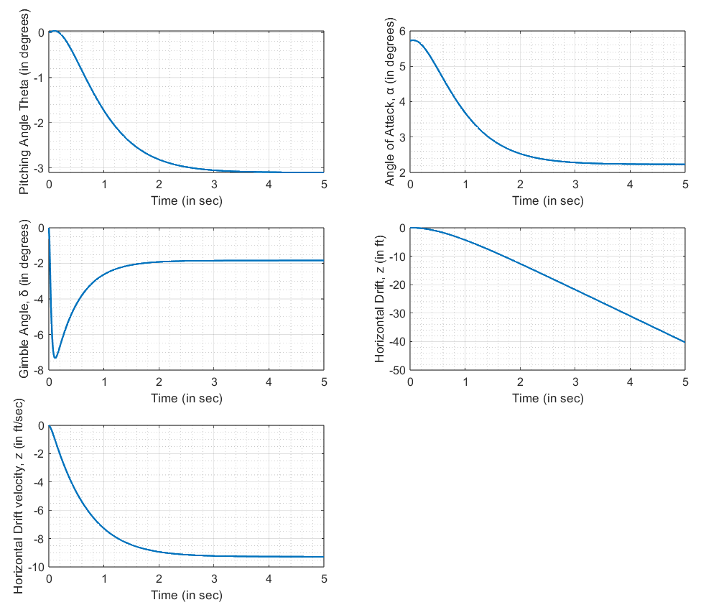

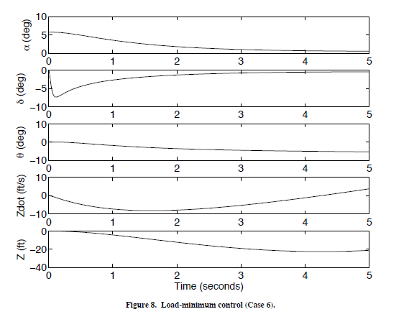
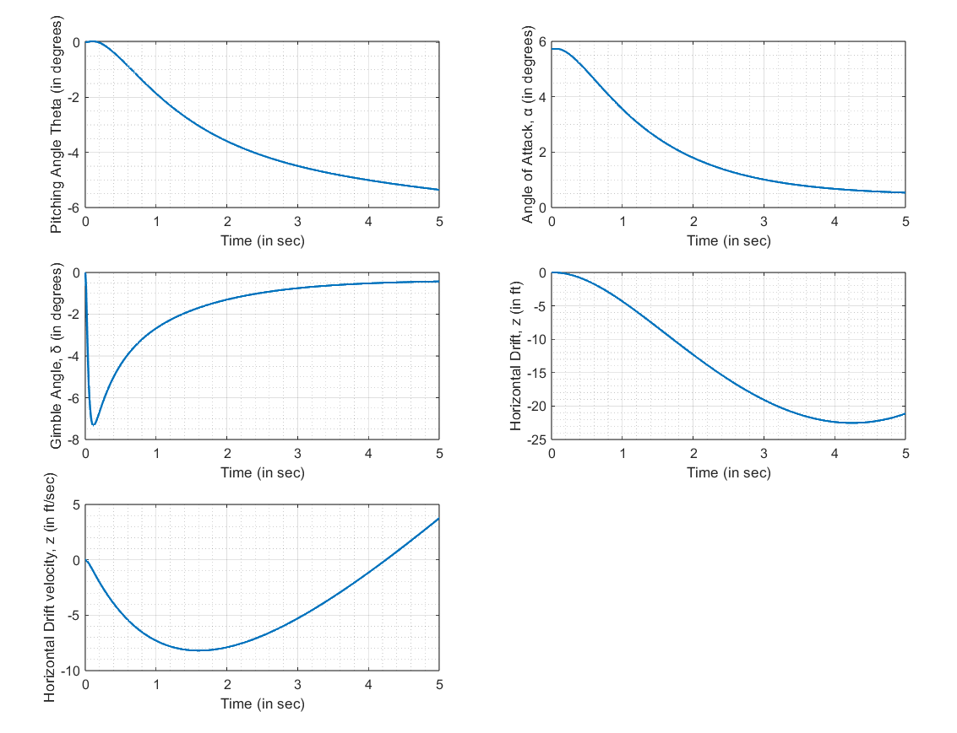
Appendix
Simulink block diagram of the system
